The Antique Fanum Martis under the future technopole of Valenciennois
Press release
7 November 2011

A team of Inrap archaeologists has begun excavating at Famars (Nord) in advance of the construction of the Mont Houy technopole, a 45 hectare technological and scientific activity center. To enable the archaeological research and site construction to coincide, an agreement concerning the excavation was signed between the Valenciennes Métropole, the developer of the technopole, Inrap, and the Valenciennes Archaeology Service. This agreement covers four years of research. In November 2011, 2500 m² will be explored. In 2012, the archaeologists will work on 3 hectares for nine months. In total, nearly 7.4 hectares will be excavated under the curation of the State (Drac Nord - Pas-de-Calais).
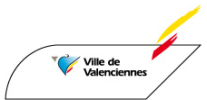
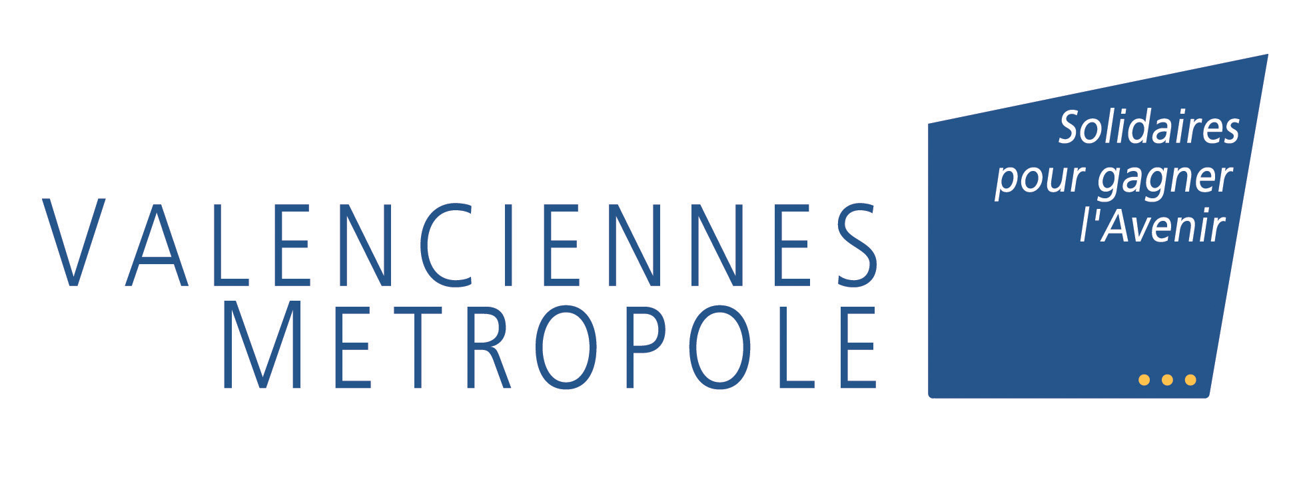

Fanum Martis
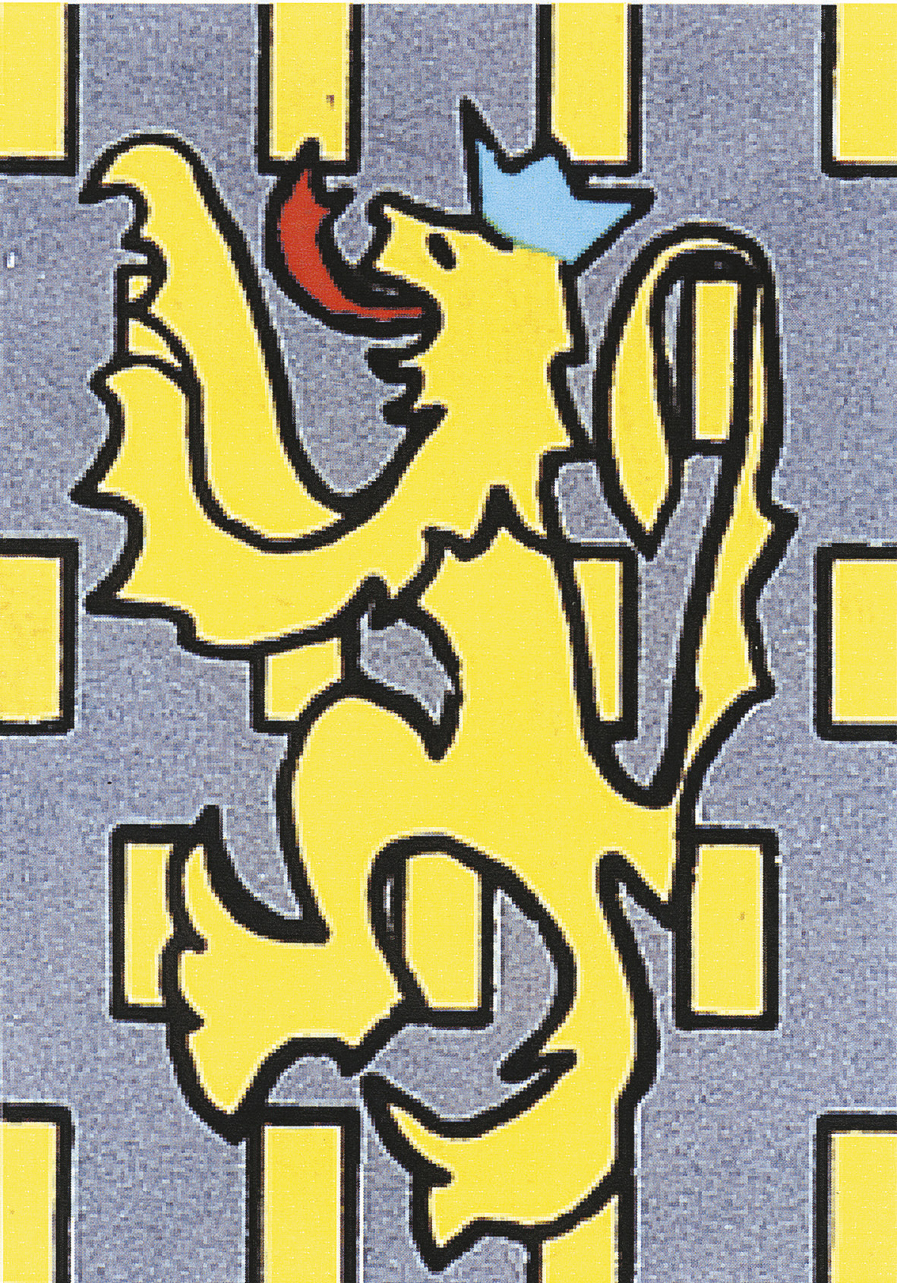
Famars, the Antique Fanum Martis, was an important city of the Early Empire. Located at the border of the Nerviens and Artrébates territories, between the Bavay-Cambrai and Bavay-Tournai routes, and along the shore of the Rhônele, a tributary of the Escaut, its geographic location contributed to its economic development. This agglomeration, which extended over nearly 150 hectares, was structured around public buildings (baths, aqueduct, temple, etc.) and defensive constructions (the wall of the castrum of the Late Roman Empire). The research realized at Famars is critical to our understanding of the economic and political zone of northern Gaul from the Early Empire to the end of Antiquity. During the Middle Ages, Fanum Martis perished due to a lack of heirs and was replaced by Valenciennes.

An Antique craftsmen quarter and military remains from the 17th century
The site of Mont Houy is located at the northern and western edge of the Antique agglomeration; the research in 2011 and 2012 will complete the mapping of the Antique city. They will also clarify the nature of this quarter where habitations and pottery, metallurgy, butchery and local sandstone working activities co-existed. The research will also concern a more recent period, represented by the remains of a military camp of the siege of Valenciennes in 1677, during which the French army of Louis XIV confronted the Dutch, Austrians and Spanish during the Thirty Years War.

A research project
In 2011, the creation of a collective research program of the Minsitry of Culture and Communication, headed by Raphaël Clotuche, an Inrap archaeologist, will ensure the study and synthesis of ancient data originating from observations and archaeological excavations in the 17th and 19th centuries, as well as those resulting from the excavations realized since the 1970’s.
This vast site will provide an opportunity for archaeologists to test new methods of research and recording of the remains excavated in the field (direct recording on graphic tablets, direct recording of topographic data, geomagnetism, archeomagnetism, etc.).

L’Inrap
With nearly 2000 collaborators and researchers, Inrap is the largest archaeological research structure in France and one of the most important in Europe. Under the direction of the Ministry of Culture and Communication and the Ministry of Higher Education, it realizes most of the archaeological diagnostic operations and excavations in partnership with private and public developers, equaling nearly 2000 sites per year in metropolitan France and its overseas territories. Its missions also include the scientific exploitation of the results and the diffusion of archaeological knowledge to the public.

Developer Valenciennes Métropole
Curation Regional Archaeology Service (Drac Nord-Pas-de-Calais)
Archaeological research Inrap and Municipal Archaeology Service of Valenciennes
Site director Jennifer Clerget, Inrap
Scientific coordination Raphaël Clotuche, Inrap

Contacts

Mahaut Tyrrell
Media communication
Inrap, Media relations and partnerships
01 40 08 80 24 - mahaut.tyrrell@inrap.fr

Elisabeth Justome
Cultural development and communication
Inrap, direction interrégionale Nord-Picardie
06 73 73 30 33 – elisabeth.justome@inrap.fr

Gautier BOUCLY
CAVM - Communication
03 27 09 63 13 - gboucly@valenciennes-metropole.fr

David Delassus
Archaeologist, in charge of general information
Valenciennes Archaeology Service
03 27 22 30 96 - ddelassus@ville-valenciennes.fr

